**BUSS-254(03)**

**Group Assignment Report**

2017150409 이소연

2017150443 김혜빈

2017150448 박소현

2017150455 최은혁

|  |  |  |  |  |  |  |
| --- | --- | --- | --- | --- | --- | --- |
| **#1** | Monthly Return | |  |  |  |  |
|  | **AXP** | **MMM** | **GS** | **MCD** | **NKE** |  |
|  | **American Express** | **3M** | **Goldman Sachs** | **McDonald's** | **Nike** | **S&P500** |
| mean | 0.0080 | 0.0100 | 0.0076 | 0.0102 | 0.0193 | 0.0032 |
| std | 0.0922 | 0.0573 | 0.0917 | 0.0563 | 0.0765 | 0.0419 |

Monthly return is calculated through Pt/Pt-1-1 using the stock price given in the table. From monthly return, mean is calculated by “=AVERAGE()” function with monthly return during 2000-01 to 2018-12 for each stock. Standard deviation is calculated by “=STDEV.S()”function with the same data.

|  |  |  |  |  |  |  |
| --- | --- | --- | --- | --- | --- | --- |
| **#2** | Monthly Excess Return | | |  |  |  |
|  | **AXP** | **MMM** | **GS** | **MCD** | **NKE** |  |
|  | **American Express** | **3M** | **Goldman Sachs** | **McDonald's** | **Nike** | **S&P500** |
| mean | 0.0066 | 0.0087 | 0.0062 | 0.0089 | 0.0179 | 0.0019 |
| std | 0.0924 | 0.0574 | 0.0917 | 0.0564 | 0.0765 | 0.0421 |

Monthly excess return is calculated by “monthly return of stock” – “monthly return of T-bills”. We get return of T-bill by dividing the given risk-free rate by 12. With monthly excess return data, mean is calculated by “=AVERAGE()” function with monthly return during 2000-01 to 2018-12 for each stock. Standard deviation is calculated by “=STDEV.S()”function with same data, just as in #1

|  |  |  |
| --- | --- | --- |
| **#3** | Market Risk Premium | 0.0019 |
|  | Average Risk-free Rate | 0.0013 |

Market risk premium is a mean of excess return of market portfolio which is S&P 500. We calculated this with “=AVERAGE()” function with the excess return data of S&P 500. Average risk free rate is mean of the return of risk free asset, T-bill. We get the number by “=AVERAGE()” function with the data of monthly return of T-bill.

|  |  |  |  |  |  |  |  |  |  |  |
| --- | --- | --- | --- | --- | --- | --- | --- | --- | --- | --- |
| **#4** |  |  |  | Alpha | *t*-stat | *p*-value | Beta | *t*-stat | *p*-value | R2 |
|  | 1 | **AXP** | **American Express** | 0.0039 | 0.8392 | 0.4022 | 1.4303 | 12.9375 | 0.0000 | 0.4255 |
|  |  |  |  |  |  |  |  |  |  |  |
|  | 2 | **MMM** | **3M** | 0.0071 | 2.3074 | 0.0219 | 0.7962 | 10.8264 | 0.0000 | 0.3415 |
|  |  |  |  |  |  |  |  |  |  |  |
|  | 3 | **GS** | **Goldman Sachs** | 0.0035 | 0.7645 | 0.4454 | 1.4459 | 13.3552 | 0.0000 | 0.4411 |
|  |  |  |  |  |  |  |  |  |  |  |
|  | 4 | **MCD** | **McDonald's** | 0.0077 | 2.3441 | 0.0199 | 0.6558 | 8.4397 | 0.0000 | 0.2396 |
|  |  |  |  |  |  |  |  |  |  |  |
|  | 5 | **NKE** | **Nike** | 0.0164 | 3.6030 | 0.0004 | 0.8070 | 7.4587 | 0.0000 | 0.1975 |

This table is a result of regression analysis with the stock prices. We regress excess return of stock on excess return of market risk premium, which is excess return of S&P 500. For example, using regression analysis tool of the excel, we put excess return of American express on the Y variables, and put excess return of S&P 500 on the X variables.

Alpha is a value of the intercept in the regression result, t-stat is the value of t statistics for alpha(intercept), and p-value is the p-value of alpha(intercept) used for testing significance. Beta is the regression coefficient of S&P 500, t-stat is the value of test statistics for beta(S&P 500), and p-value is the p-value of S&P 500. R2 is a value of coefficient of determination.

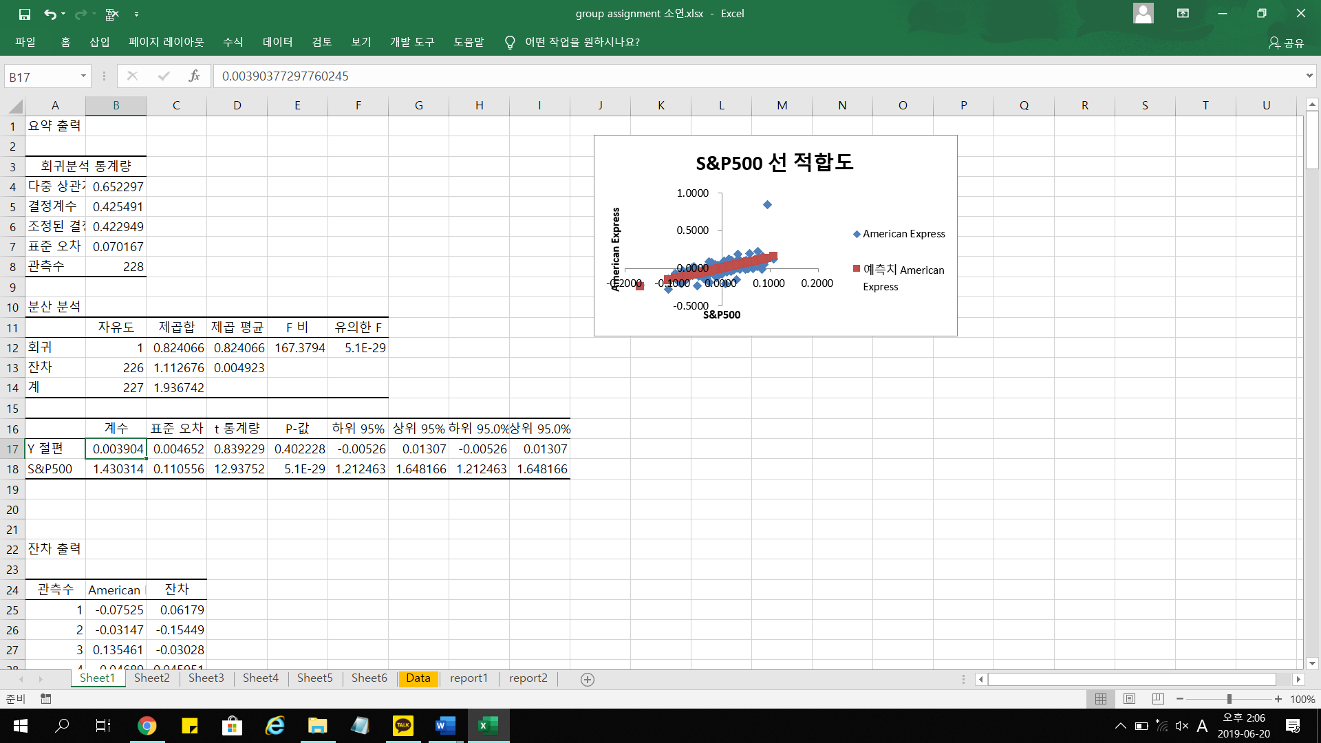

Captured picture is an example of the regression output

|  |  |  |  |  |  |  |  |  |
| --- | --- | --- | --- | --- | --- | --- | --- | --- |
|  |  |  |  | w1 | w2 | w3 | w4 | w5 |
| **#5** |  |  |  | 0 | 0 | 0 | 0 | 0 |
|  |  |  | Covariance | **AXP** | **MMM** | **GS** | **MCD** | **NKE** |
|  | w1 | 0 | **AXP** | 0.008505 | 0.002675 | 0.003447 | 0.001587 | 0.002768 |
|  | w2 | 0 | **MMM** | 0.002675 | 0.003285 | 0.001778 | 0.000853 | 0.001554 |
|  | w3 | 0 | **GS** | 0.003447 | 0.001778 | 0.008413 | 0.001283 | 0.002088 |
|  | w4 | 0 | **MCD** | 0.001587 | 0.000853 | 0.001283 | 0.003174 | 0.001606 |
|  | w5 | 0 | **NKE** | 0.002768 | 0.001554 | 0.002088 | 0.001606 | 0.00585 |

We can covariance with “=COVARIANCE.S()” function. Using the monthly return or excess return of each stocks, (since covariance is independent to addition or subtraction), we can calculate the covariance of the returns on each two sets of stocks. For example, covariance of the returns on AXP and MMM can be calculated by =COVARIANCE.S(I5:I232, J5:J232).

**#6**

|  |  |  |  |  |  |  |  |  |
| --- | --- | --- | --- | --- | --- | --- | --- | --- |
| MV Frontier | w1 | w2 | w3 | w4 | w5 | min var | min std | mean |
| 0.029 | -0.53635 | 0.14861 | -0.33733 | -0.12071 | 1.84578 | 0.01643 | 0.12818 | 0.029 |
| 0.025 | -0.42876 | 0.21271 | -0.24753 | 0.00520 | 1.45838 | 0.01074 | 0.10362 | 0.025 |
| 0.021 | -0.32117 | 0.27681 | -0.15773 | 0.13110 | 1.07098 | 0.00646 | 0.08037 | 0.021 |
| 0.017 | -0.21358 | 0.34091 | -0.06792 | 0.25700 | 0.68359 | 0.00360 | 0.05997 | 0.017 |
| 0.013 | -0.10599 | 0.40501 | 0.02188 | 0.38290 | 0.29619 | 0.00215 | 0.04637 | 0.013 |
| 0.009 | 0.00160 | 0.46912 | 0.11168 | 0.50881 | -0.09120 | 0.00212 | 0.04604 | 0.009 |
| 0.005 | 0.10919 | 0.53322 | 0.20149 | 0.63471 | -0.47860 | 0.00351 | 0.05921 | 0.005 |
| 0.001 | 0.21678 | 0.59732 | 0.29129 | 0.76061 | -0.86600 | 0.00631 | 0.07942 | 0.001 |

We can use the solver for the minimum variance frontier. Our target is to minimize variance, so choose target=pf Var, minimize. The variable cells are the weight on stocks variable (w1, w2, w3, w4, w5), since we are choosing stock weights through which we can get minimum variance at a given mean. Finally, we have two constraints: (1) the sum of stock weights should equal 1 and (2) the portfolio mean should be the given value of mean. The solver setting is attached below.

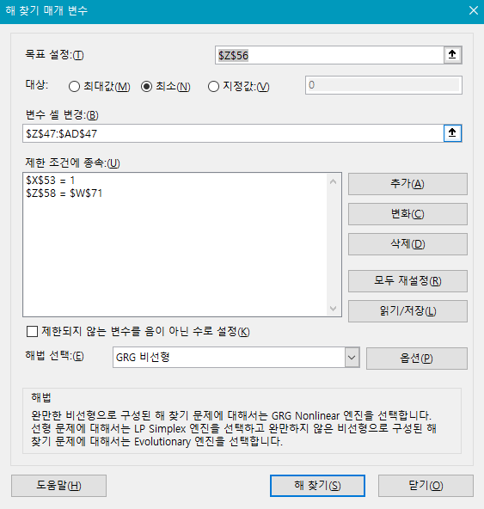

Setting the solver settings as above, we can get the weights as well as the portfolio variance, given the target mean.



For example, the results for the mean=0.0290 is as above. It can be interpreted that for the given mean 0.0290, the portfolio with smallest variance can be formed with the weights from the result, and the corresponding variance will be 0.0164. Graphically, if we draw a horizontal line for E(r)=0.0290 it would meet the MVF curve at std(sigma)=0.1282.

Repeating the procedure for each of the mean values, we can earn the MVF table.

|  |  |  |  |  |  |  |  |  |  |
| --- | --- | --- | --- | --- | --- | --- | --- | --- | --- |
| **#7** | Max Sharpe Ratio | |  | 0.2635 |  |  |  |  |  |
|  |  |  | Mean | 0.0155 |  |  |  |  |  |
|  |  |  | Variance | 0.0029 |  |  |  |  |  |
|  |  |  | Std | 0.0539 |  |  |  |  |  |
|  |  |  |  |  |  |  |  |  |  |
|  |  | w1 | w2 | w3 | w4 | w5 | var | std | mean |
|  |  | -0.174203 | 0.364374 | -0.035045 | 0.303095 | 0.541779 | 0.002903 | 0.05388 | 0.015536 |

To get the the optimal risky portfolio of the five stocks, we again use the MS Excel Solver function to get the ORP with the maximum sharpe ratio. Our target is to maximise pf Sharpe ratio, so choose target=pf S-ratio, maximise. The variable cells are the weight on stocks variable (w1, w2, w3, w4, w5), since we are choosing stock weights of a portfolio through which we can get the maximum Sharpe ratio when combined with the risk-free asset. Finally, we have one constraint: the sum of stock weights should equal 1. The solver setting is attached below.

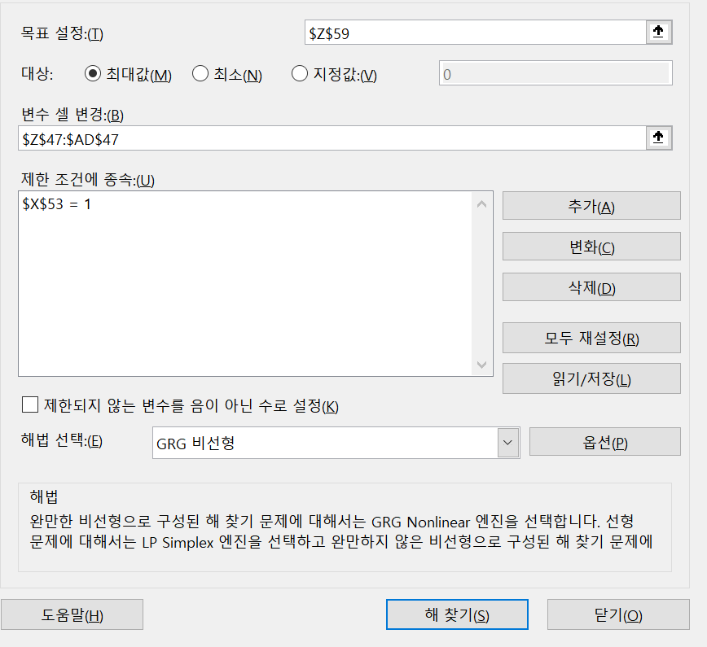

Now we get the maximised pf S-ratio and each weight. Since weights are newly filled, the adjusted pf Var and pf Mean are also automatically renewed. We copy and paste these values to fill in the yellow shaded tables.

|  |  |  |  |  |  |
| --- | --- | --- | --- | --- | --- |
| **#8** | Treynor-Black Sharpe Ratio | | | 0.0646 |  |
|  |  |  |  |  |  |
|  |  | weight on passive portfolio | | | 0.1984 |
|  |  | weight on active portfolio | | | 0.8016 |
|  |  |  | weight on MCD | | 0.5780 |
|  |  |  | weight on NKE | | 0.2236 |

Here, we first construct a new table of an active portfolio A that consists of MCD and NIKE where each (monthly) alphas of the two stocks are 0.0020 and 0.0015, respectively. See the table below. From the result of the regression analysis of MCD and NIKE done in previous problems, we get the estimate for beta and var(e) by the regression coefficient of S&P500 and MSE(or Mean Squared Residual), respectively. Then we get the optimal weight for each stock in this active portfolio stock by calculating =(alpha/var(e)[stock i])/sum. With this weights, we calculate each alpha and beta of the active pf by calculating weighted average of each individual components. For var(e), we have sum of wi^2*var(ei). Then with the formula of Treynor-Black model, we calculate w(0), w*(A), and w*(M), using the S&P 500 index fund as a passive, market portfolio. All the explained results are given below by the table.

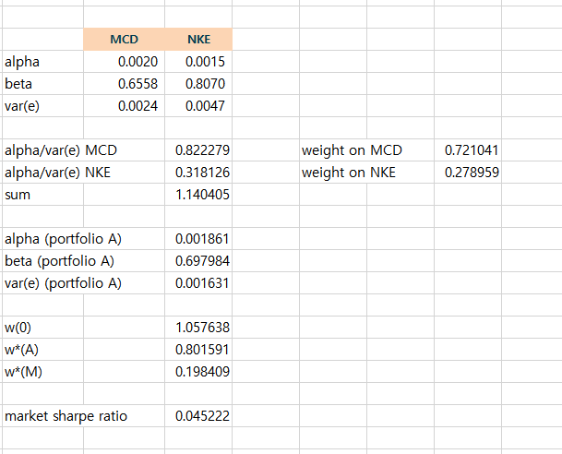

Since we have calculated the weight on passive portfolio and the weight on active portfolio by the formula, we fill in the yellow blanks. For the weight on MCD and NKE, we multiply the weight on active pf and the weight on each individual stock inside the active pf. For example, for MCD, we get =AA92*AI96=0.721041*0.801591=0.5780

Finally, we calculate the Treynor-Black Sharpe Ratio by

=SQRT((market sharpe ratio)^2+(alpha of portfolio A)^2/(var(e) of portfolio A))

=SQRT(AE108^2+AE100^2/AE102)

=0.0646